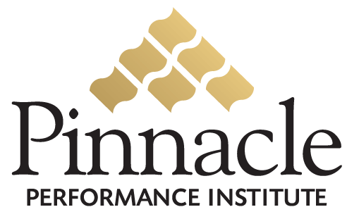

Pinnacle Sales Script

MLM Companies

RESEARCH: (Customer Support)
Hi __________, my name is _________ from Dallas, TX and I’m trying to get some information on training for new distributors.
Can you tell me what training is available?
Does the company have any formal training possibly on the Internet?
Who in the company is in charge of distributor training? (Name, phone/ext, forward?)

VOICE MAIL: (Distributor Training)
Hi __________, my name is _________ and I’m with the Pinnacle Performance Institute in Dallas, TX.
I’m calling about a solution we implemented for EcoQuest International, who we showed how to increase their sales by more than 20% by improving the performance of their 85,000 distributors.
I’ll contact you next week or you can call me on my cell phone at ______________.

APPOINTMENT: (Distributor Training)
Hi __________, my name is _________ and I’m with the Pinnacle Performance Institute in Dallas, TX.
I’m calling regarding EcoQuest International, an international marketing company with 85,000 distributors.
I’m back in Dallas for the next week and I’d like to stop by and introduce myself and show you how we have shown EcoQuest how to increase their sales by more than 20% by improving the performance of their distributors.
Is there a good time that I can stop by for 30 minutes?
{Who is Pinnacle?} {What do you have?}
Pinnacle is a research and development Institute that shows companies how to clone their top performers to significantly improve their profits.
We’re currently working with several large organizations like DHL with 11,000 couriers, Yum Brands who owns Pizza Hut, Kentucky Fried Chicken, Taco Bell, Long John Silvers, and A&W, 13,000 employees of Cinemark in North, Central and South America, the Maid-Brigade national franchises, and EcoQuest an international manufacturer and marketer of air purification systems.
We do this with a very affordable online Performance Enhancement Solution customized to your specific needs.
{How does it work?} {What does it cost?}
Pinnacle has so many features and benefits; I’d like to meet with you to better understand your exact needs so that I can give you an accurate response.
It’s not expensive; we even have a program that’s free to all your distributors.
I’d really like to stop by for 30 minutes and show you.
When would be a good time?

